**world conquest SPRINT [No.] design documet**

A Design Document for the Game ‘World Conquest’ for Raffle Games

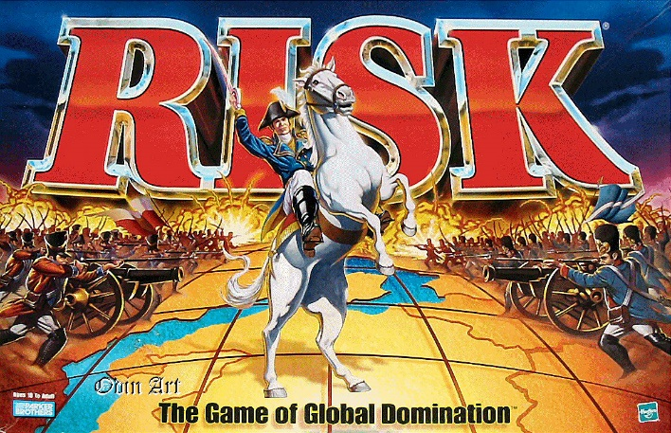

February 8, 1993

Team one

University of Sussex

Contents

Sprint II 2

Design Objectives 2

UI Design 2

Class table 2

UML Diagrams 2

Skeleton Code 2

Updated Design/Design Changes 2

Conclusion 2

References 2

# Sprint II

## Design Objectives

For this sprint, our implementation aims are:

## UI Design

## Class table

|  |  |  |  |
| --- | --- | --- | --- |
| Class No. | Class Name | Attributes | Comments |
| 1 |  |  |  |

## UML Diagrams

## Skeleton Code

## Updated Design/Design Changes

# Conclusion

[Analysis of Design and how it related to Implementation]

# References

Parker Brothers, 1993. *RISK - The World Conquest Game,* Beverly: Tonka Corporation.